December 31, 2025
Assignment-2
Hajra Sarwar
2023-BSE(5A)-022
Cloud Computing
engr. waqas salim
Advanced Terraform & Nginx Multi-Tier Architecture

Table of Contents
- Executive Summary ……………………………………………………………….....2
- Brief overview of the assignment ………………………………………………2
- Infrastructure deployed …………………………………………………………2
- Key achievements ………………………………………………………………2
- Architecture Design ………………………………………………………………......2
- Architecture diagram ……………………………………………………………2
- Component descriptions ………………………………………………………...2
- Network topology ……………………………………………………………….3
- Security design ……………………………………………………………….....3
- Implementation Details ……………………………………………………………....4
- Part 1: Infrastructure setup ……………………………………………………...4
- Part 2: Webserver module ………………………………………………………8
- Part 3: Server scripts ……………………………………………………………10
- Part 4: Deployment ……………………………………………………………..11
- Part 5: Testing and verification …………………………………………………14
- Part 6: Cleanup …………………………………………………………….........19
- Testing Results ………………………………………………………………………..20
- Load balancing tests …………………………………………………………….20
- Cache performance tests ………………………………………………………...20
- High availability tests …………………………………………………………...20
- Security tests …………………………………………………………….............20
- Performance metrics …………………………………………………………….20
- Challenges & Solutions …………………………………………………………….....21
- Problems encountered …………………………………………………………...21
- How you solved them ……………………………………………………………21
- Lessons learned …………………………………………………………….........21
- Conclusion ……………………………………………………………..........................21
- Summary of work completed ……………………………………………………21
- Skills acquired ……………………………………………………………...........21
- Future improvements …………………………………………………………….21
- Appendices ……………………………………………………………..........................21
- Complete code listings …………………………………………………………...21
- Configuration files …………………………………………………………….....21
- Additional screenshots …………………………………………………………...21
- References ……………………………………………………………..................21

  - Executive Summary
This assignment focused on designing and deploying a high-availability multi-tier web infrastructure on AWS using Terraform modules and Nginx as a reverse proxy/load balancer. The objective was to demonstrate Infrastructure as Code best practices, advanced Nginx configurations (SSL, caching, load balancing), secure networking, and high availability with failover.
Infrastructure Deployed:
- Nginx Server: Acts as reverse proxy/load balancer with HTTPS, caching, and security headers.
- Backend Web Servers: Three EC2 instances (web-1, web-2 as primary, web-3 as backup) running Apache HTTP Server.
- Networking: Custom VPC, public subnet, internet gateway, route table.
- Security: Nginx and backend security groups with proper ingress/egress rules.
- Automation: Terraform modules for networking, security, and web servers; shell scripts for server setup.
- Monitoring & Testing: Load balancing verification, caching functionality, backup server failover, SSL/TLS validation.
Key Achievements:
- Modular Terraform setup enabling reusability and scalability.
- Successful deployment of 4 EC2 instances with automated configuration.
- Nginx reverse proxy configured with load balancing, caching, HTTPS, and security headers.
- High availability tested using primary server failure simulation; backup server successfully activated.
- Documentation and scripts created to allow easy replication and maintenance.

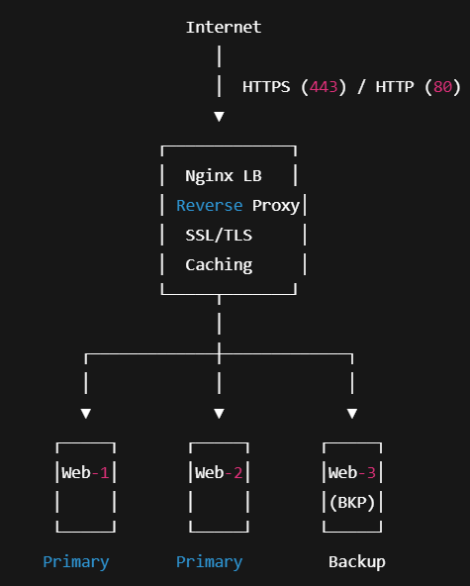
  - Architecture Design

2.1 Architecture Diagram

The diagram shows the overall flow of the web infrastructure. Users access the system from the Internet via HTTP/HTTPS. Traffic first reaches the Nginx load balancer, which handles SSL, caching, and distributes requests to the backend servers. Web-1 and Web-2 serve as primary servers, while Web-3 acts as a backup for high availability. Security groups control access, allowing only necessary traffic to Nginx and the backend servers. This setup ensures secure, load-balanced, and highly available web service.

2.2 Component descriptions
- Nginx Server (LB/Reverse Proxy):
  - Distributes traffic to primary web servers using round-robin load balancing.
  - Serves HTTPS traffic with a self-signed certificate.
  - Caching implemented to improve performance (X-Cache-Status HIT/MISS).
  - Health check endpoint ensures backend availability.
  - Security headers: HSTS, X-Frame-Options, X-Content-Type-Options, X-XSS-Protection.
- Backend Web Servers (Web-1, Web-2, Web-3):
  - Apache HTTP server deployed via Terraform module.
  - Custom HTML page showing hostname, private/public IP, deployment timestamp, and status.
  - Web-1 and Web-2 are primary; Web-3 is backup for failover.
  - Scripts utilize IMDSv2 for secure metadata access.
- Networking:
  - VPC with custom CIDR block.
  - Public subnet with map_public_ip_on_launch enabled.
  - Internet Gateway attached for public connectivity.
  - Route Table associated with subnet for internet routing.
- Security Design:
  - Nginx Security Group: Ports 22 (SSH) restricted to your IP, 80/443 open to all.
  - Backend Security Group: Port 22 restricted to your IP, port 80 restricted to Nginx SG only.
  - All resources tagged with environment and project details for clarity.
- High Availability:
  - Backup web server automatically handles traffic if primary servers fail.
  - Load balancing verified through repeated requests showing traffic alternation.
  - Server health monitored via Nginx logs and optional bonus health check scripts.
- Deployment Automation:
  - Terraform modules for networking, security, and webserver configuration.
  - Scripts for Nginx and Apache ensure consistent, repeatable setup.
  - Outputs provided to guide manual updates for backend IPs in Nginx.

2.3 Network topology

The deployed infrastructure follows a multi-tier architecture with high availability and proper network segmentation. The topology is as follows:
Key Points:
- VPC: Single VPC with CIDR 10.0.0.0/16.
- Subnet: Public subnet 10.0.10.0/24 hosting all EC2 instances.
- Internet Gateway: Provides internet access to Nginx and backend servers.
- Routing: Route table attached to subnet, routes 0.0.0.0/0 via IGW.
- High Availability: Web-3 acts as a backup server, only serving traffic if Web-1 or Web-2 fail.

2.3 Security Design
Security is enforced at multiple layers using AWS Security Groups and TLS/HTTPS.
1. Nginx Security Group
- Ingress Rules:
  - SSH (22) → Only from your IP
  - HTTP (80) → Anywhere (0.0.0.0/0)
  - HTTPS (443) → Anywhere (0.0.0.0/0)
- Egress: All traffic allowed
2. Backend Security Group
- Ingress Rules:
  - SSH (22) → Only from your IP
  - HTTP (80) → Only from Nginx security group
- Egress: All traffic allowed
Additional Measures:
- SSL/TLS: Self-signed certificate generated on Nginx, enabling HTTPS.
- Security Headers: Added Strict-Transport-Security, X-Frame-Options, X-Content-Type-Options, X-XSS-Protection.
- SSH Key Management: EC2 key pairs generated per instance, private keys never committed.
- IAM Principle: Least privilege applied; only required resources have permissions.

  - Implementation Details

Part 1: Infrastructure setup
  - Project structure (create files & folders)

TASK:
- Create all necessary files and directories
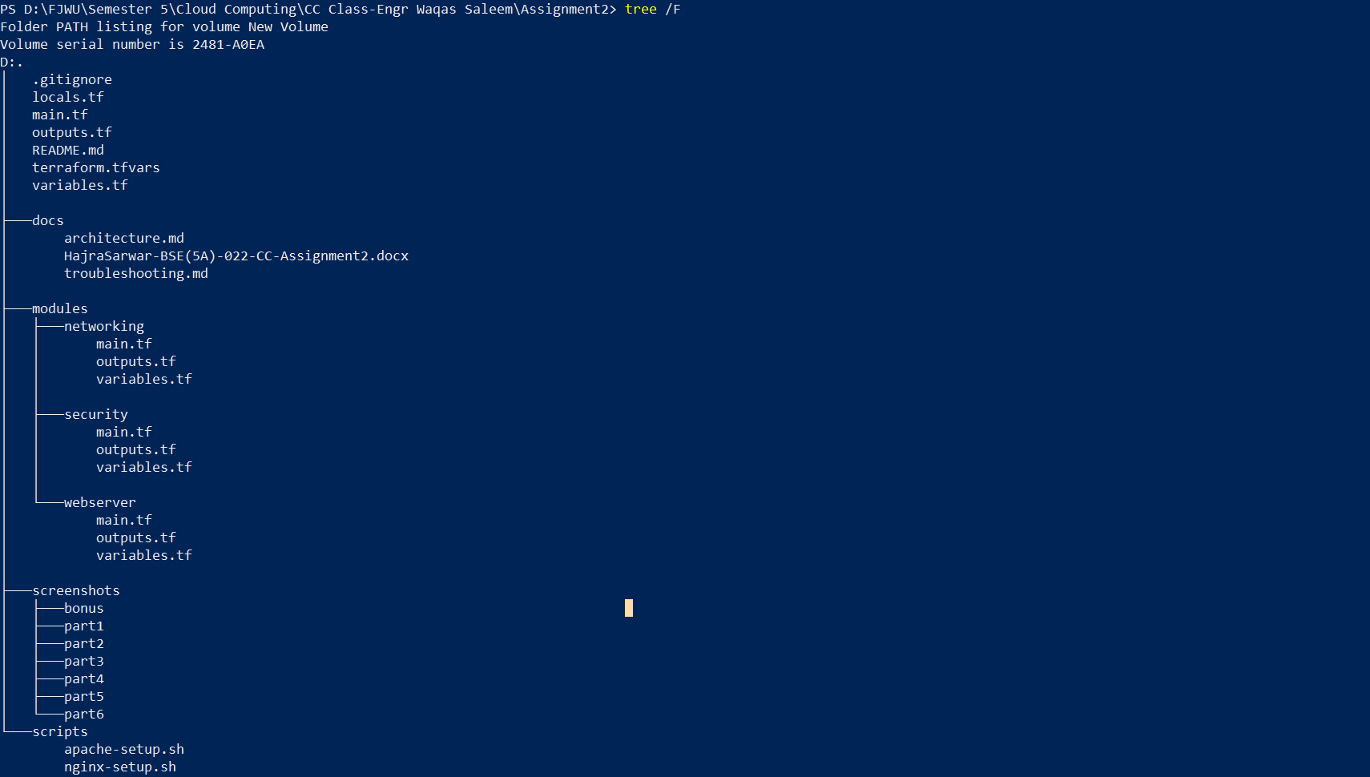

- Implement proper .gitignore to exclude sensitive files
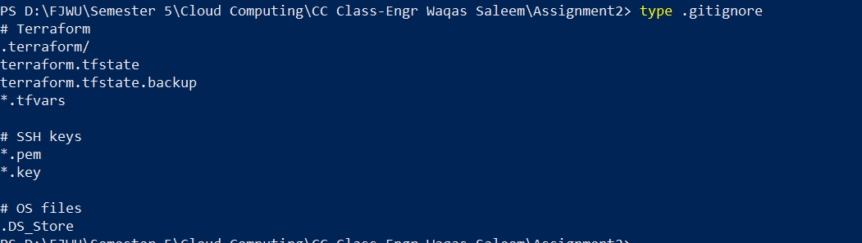

- Document the project structure in README.md
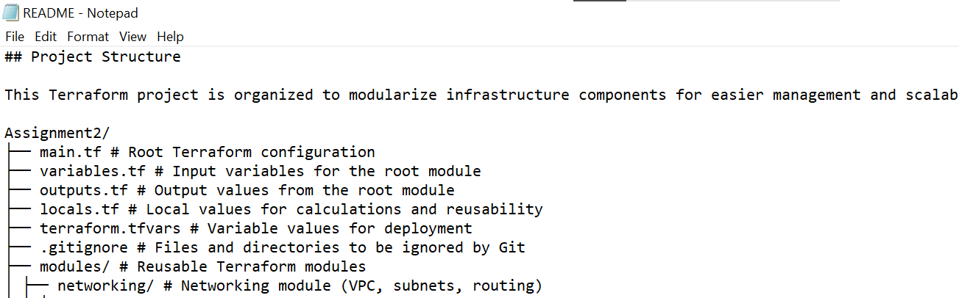

  - Variable configuration

TASK:
  - Add validation rules for CIDR blocks
  - Add descriptions for all variables
Variables.tf:
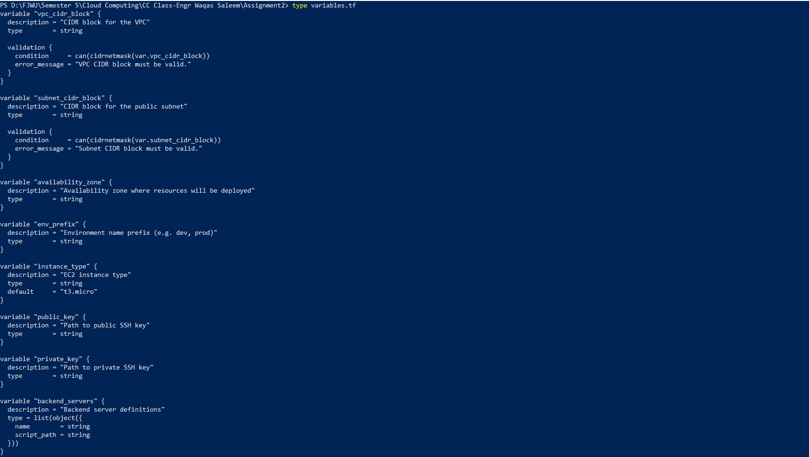
  - Set appropriate defaults where applicable
  - Populate terraform.tfvars with your values
Terraform.tfvars:
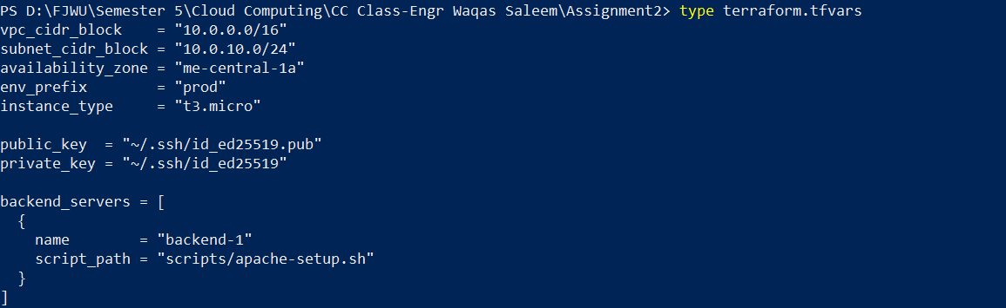

  - Networking module

TASK:
  - Create VPC resource

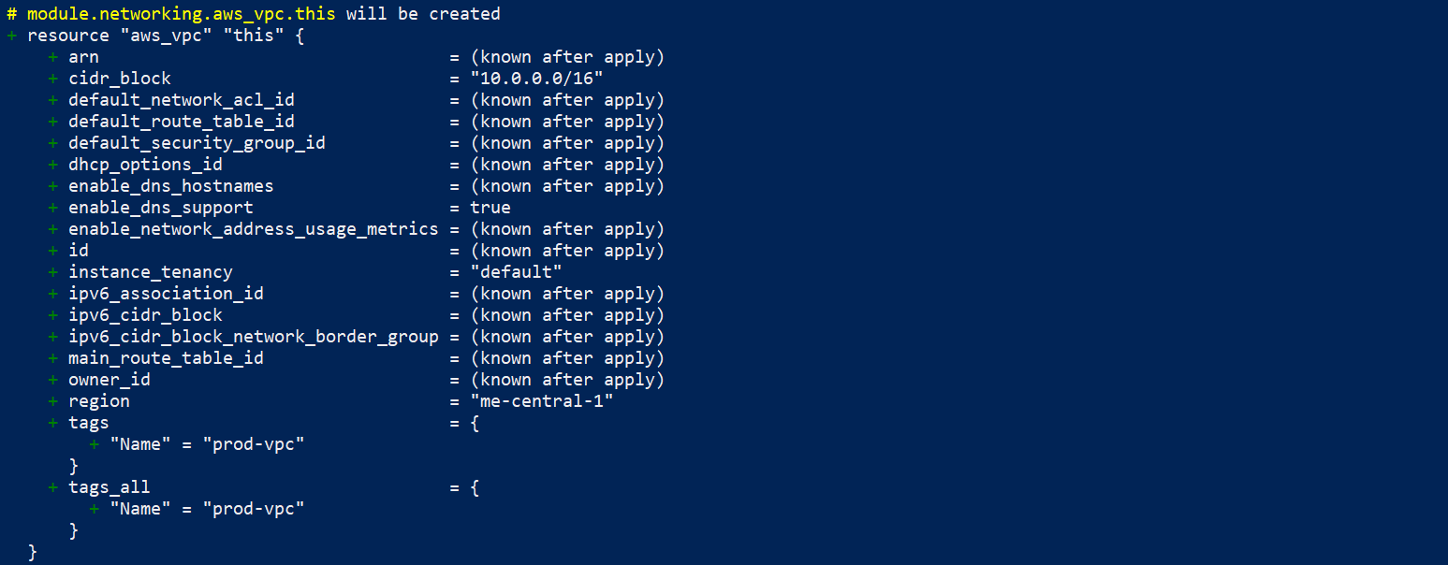
  - Create subnet with map_public_ip_on_launch = true
  - Create and attach Internet Gateway

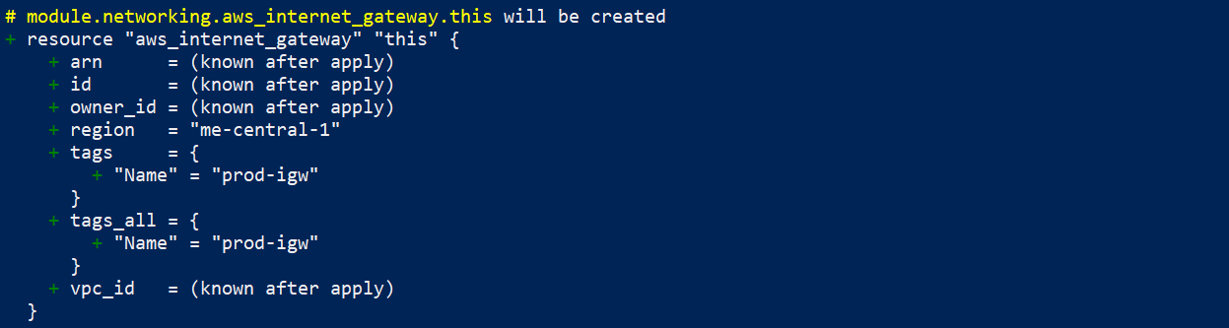
  - Configure routing table

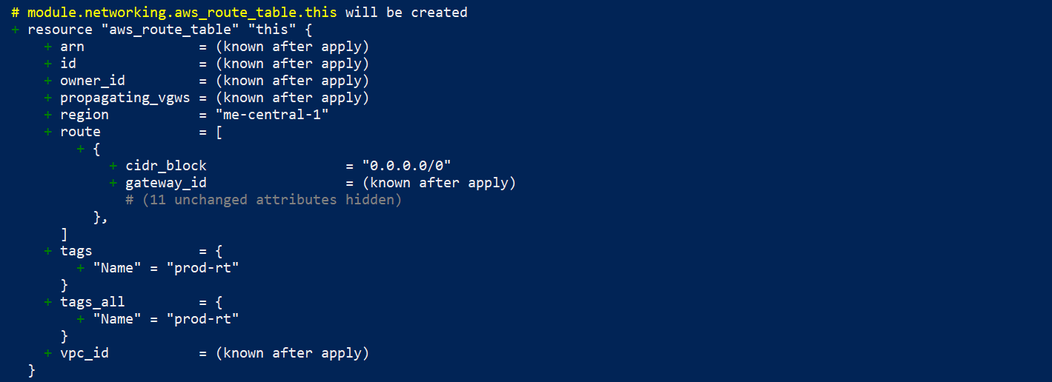
  - Add proper tags to all resources using env_prefix

Outputs.tf:
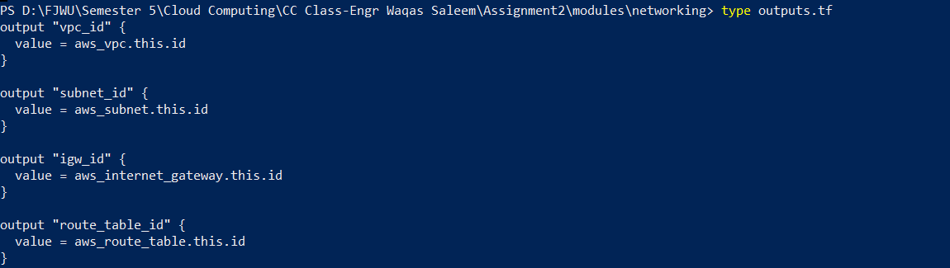
main.tf:
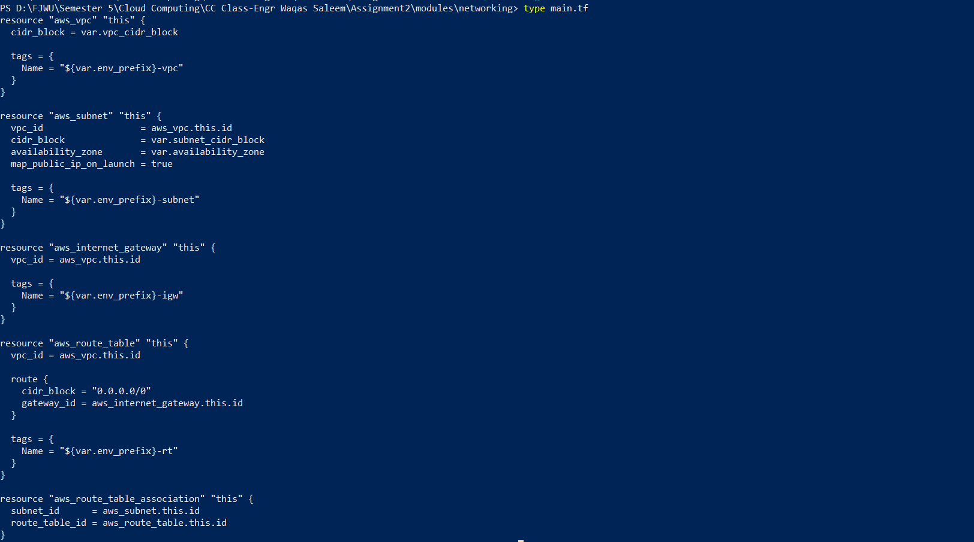

1.4 Security module
TASK:
  - Create Nginx security group with appropriate rules
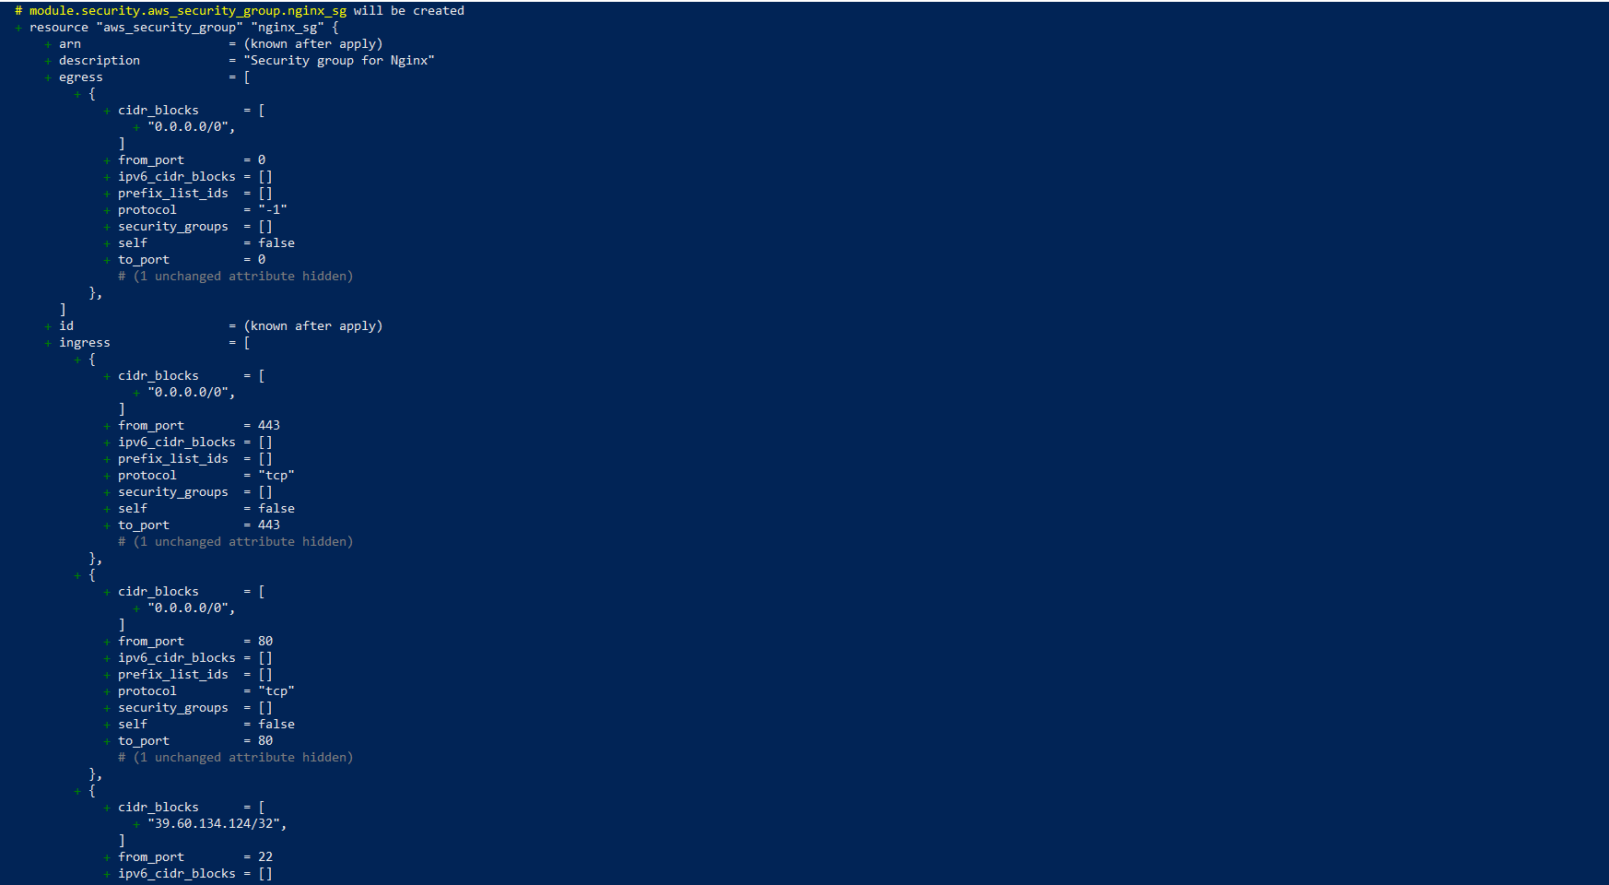
  - Create backend security group with appropriate rules

  - Use security group IDs for backend ingress (not CIDR blocks)
  - Add descriptive names and tags
main.tf:
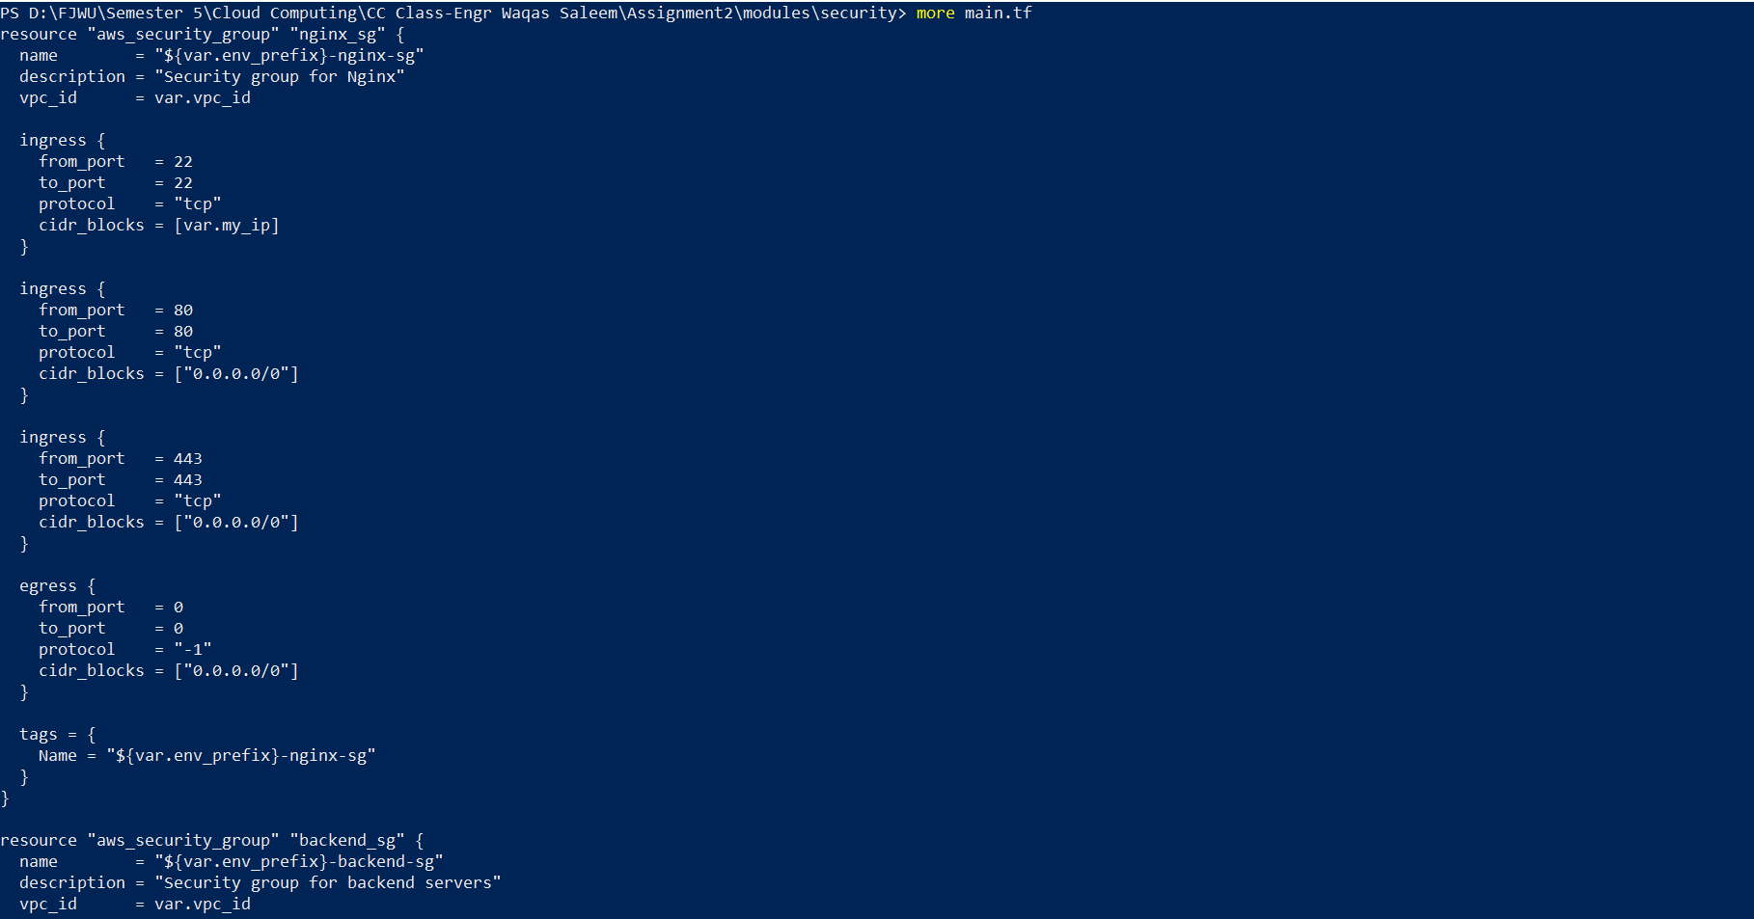
AWS Console:
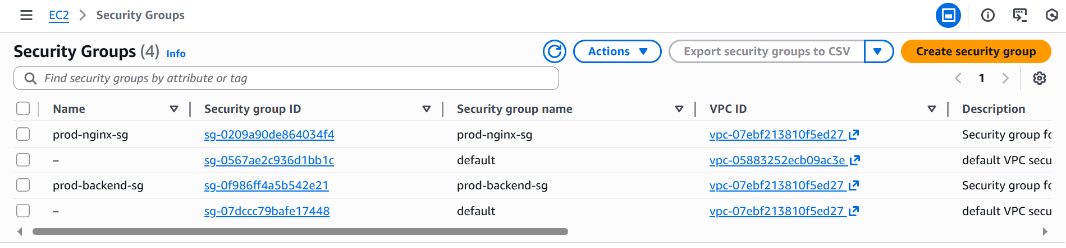

  - Locals configuration

TASK:
  - Implement dynamic IP detection
  - Define common tags
  - Define backend server list
  - Add any other reusable local values
locals.tf:
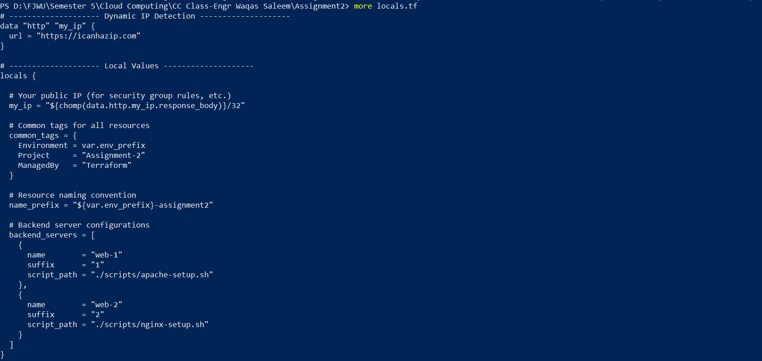

Part 2: Webserver module

2.1 Module design (webserver module)
TASK:
  - Create variables. tf with all required variables
  - Create main.tf with key pair and instance resources
  - Create outputs.tf with all required outputs
  - Ensure module is reusable for both Nginx and backend servers
Variables.tf:
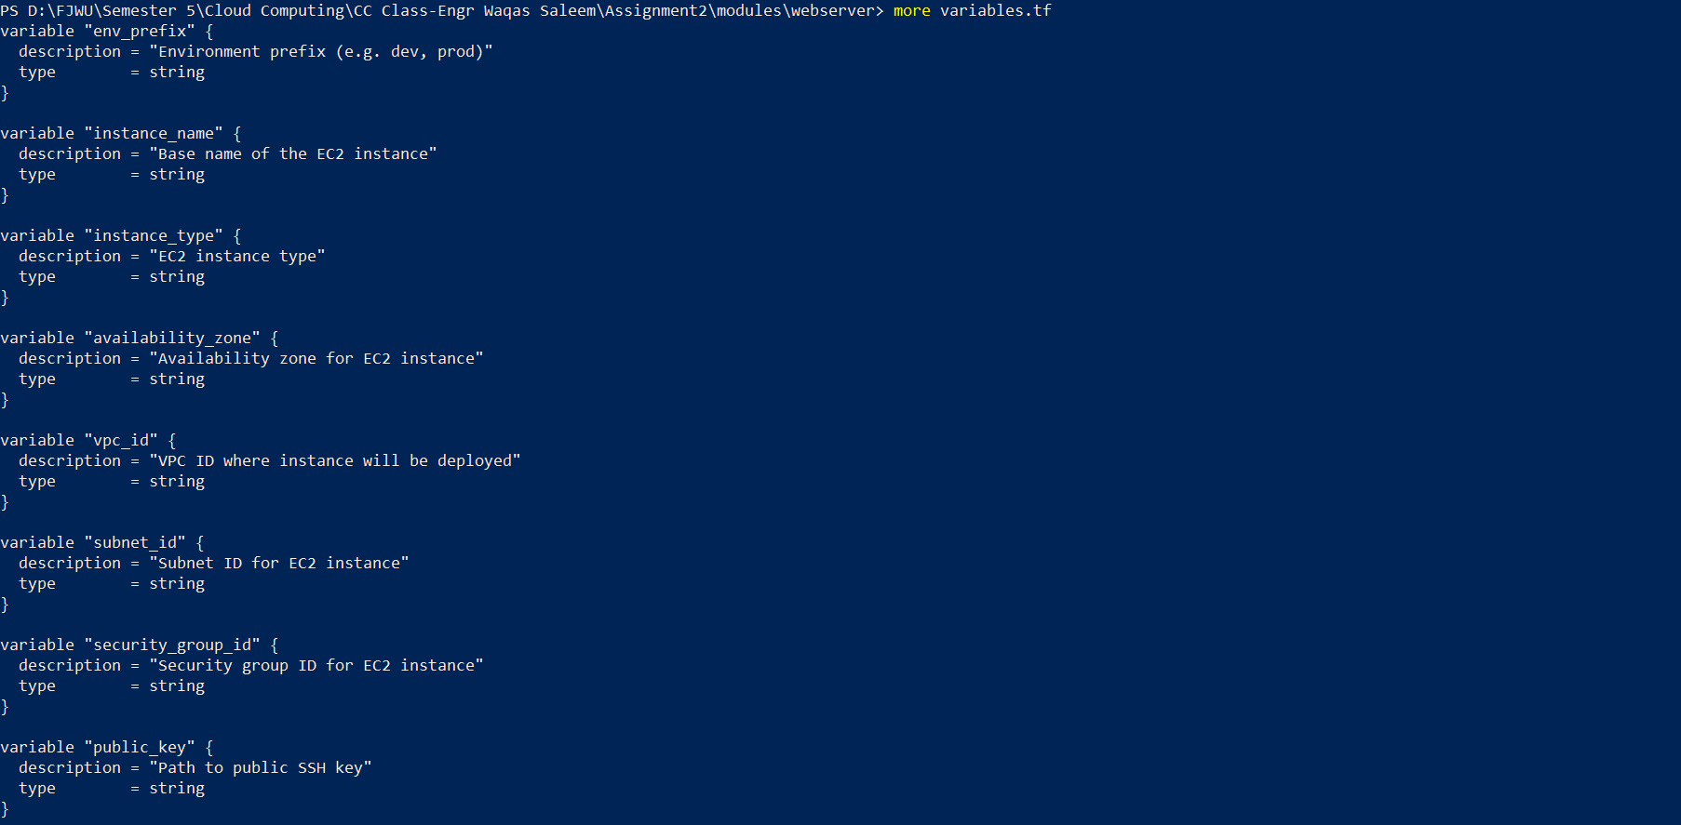
main.tf:
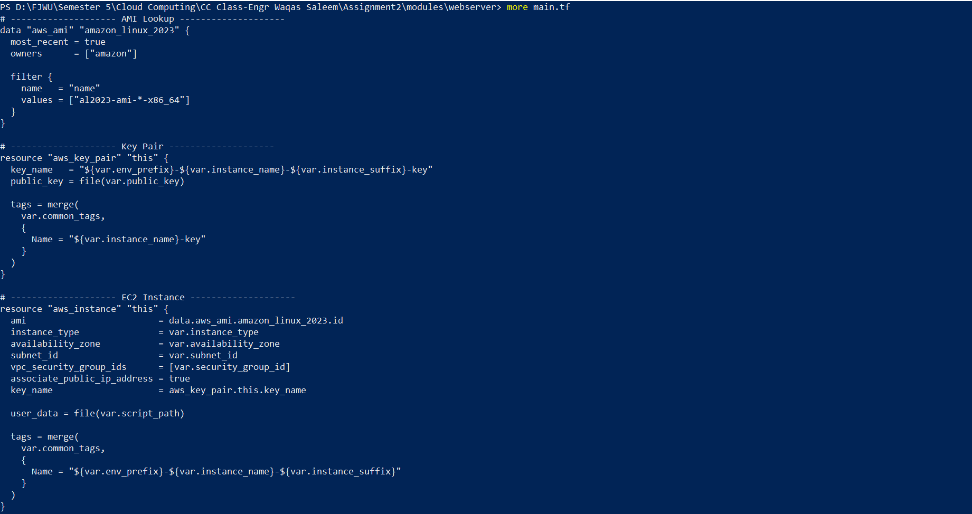
Outputs.tf:
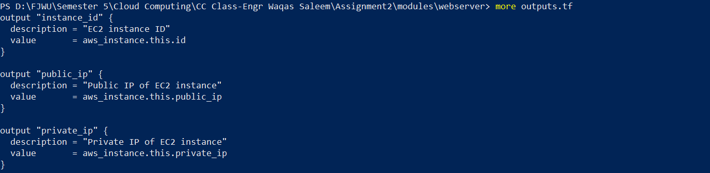

2.2 Module usage (instantiation)
TASK:
  - Create Nginx server module instance
  - Create backend server module instances using for_each
  - Ensure proper security group assignment
  - Pass all required variables
main.tf:
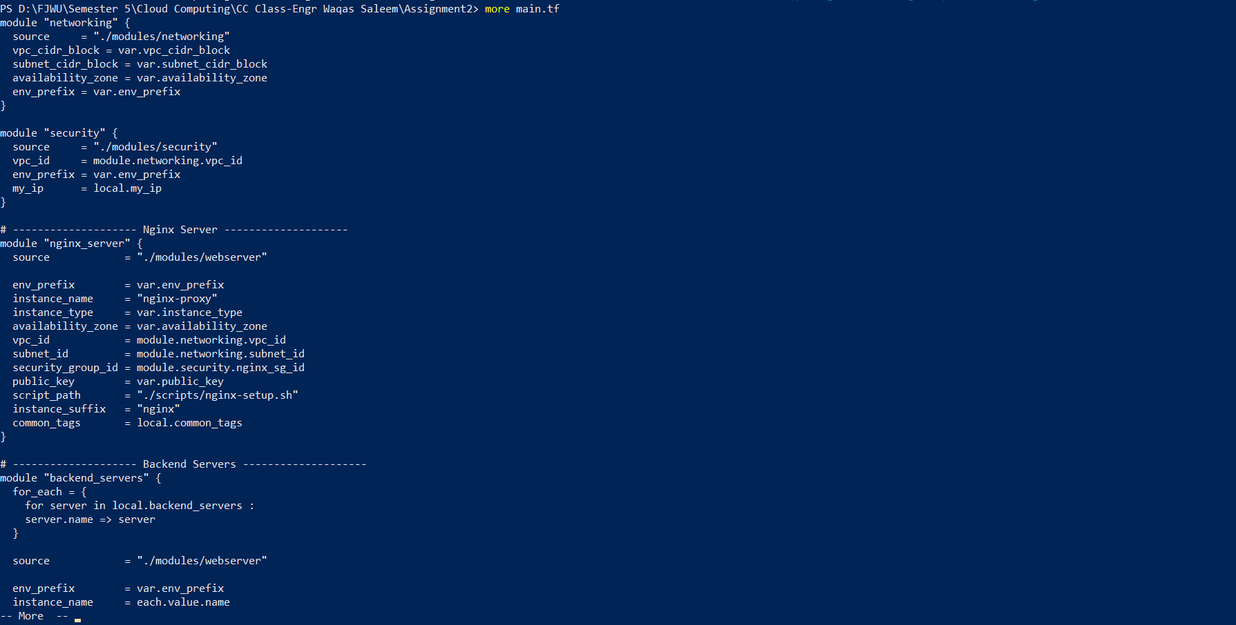

Part 3: Server configuration scripts

3.1 Apache backend script (apache-setup.sh)
TASK:
  - Create the script with all required features
  - Ensure it uses IMDSv2 for metadata
  - Create visually appealing HTML output
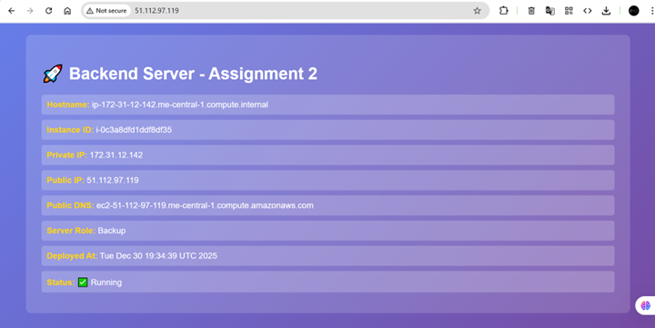
  - Make script executable
  - Test script independently
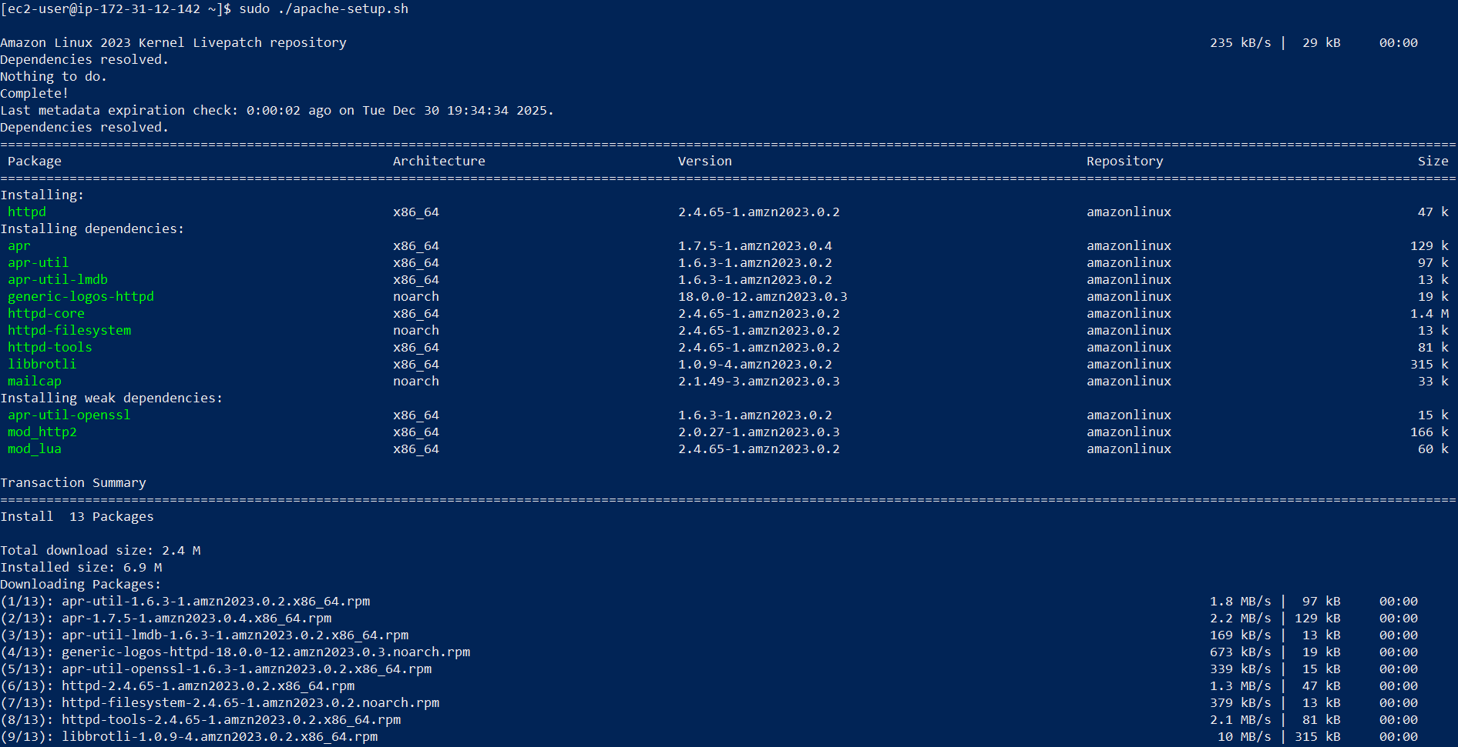
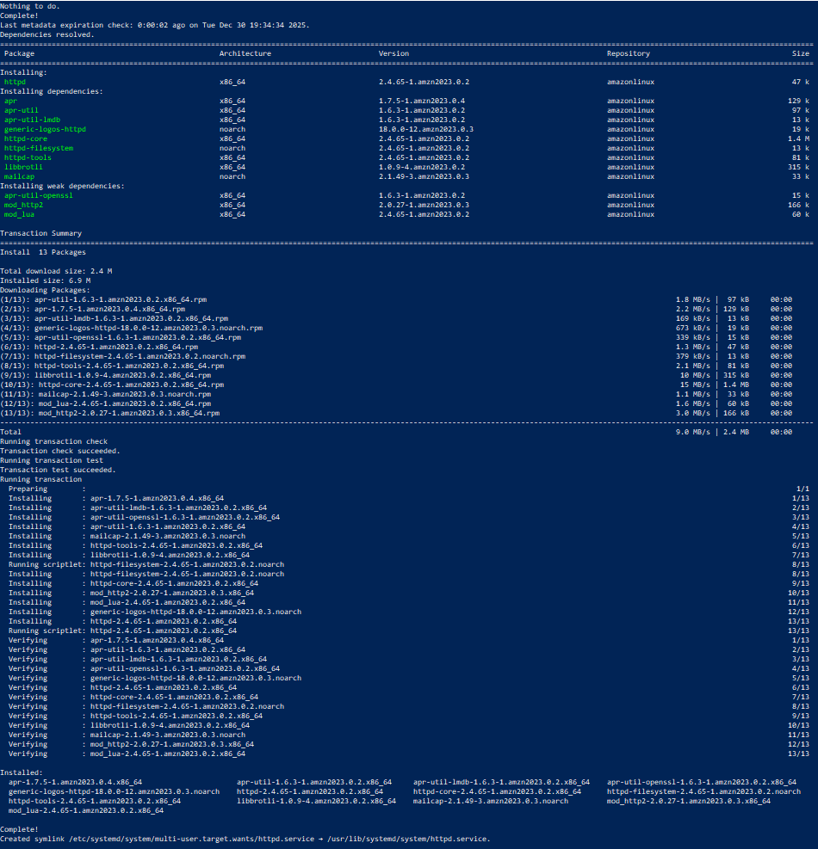

  - Nginx server setup script (nginx-setup.sh)

TASK:
  - Create script with SSL certificate generation
  - Configure upstream with placeholder IPs
  - Implement caching
  - Add security headers
  - Configure HTTP to HTTPS redirect
  - Add health check endpoint

nginx-setup.sh:

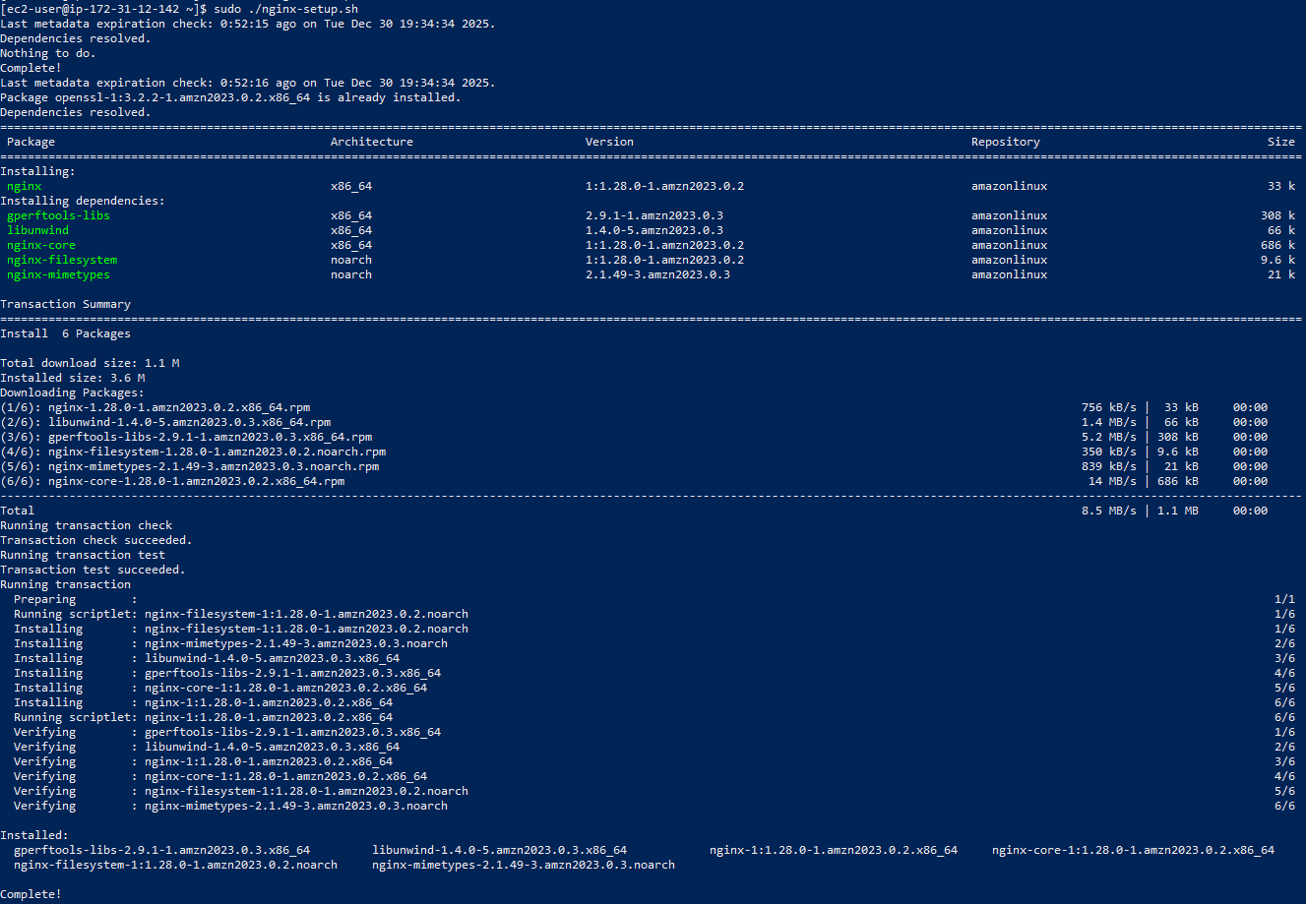

default_page of nginx:

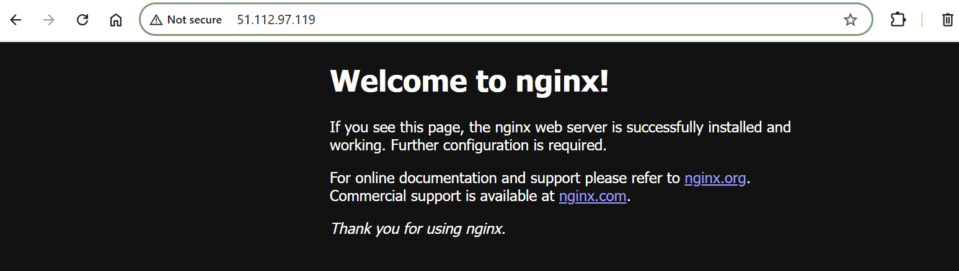

Part 4: Infrastructure Deployment

4.1 Initial Deployment (SSH keys, terraform init/plan/apply)

TASK:
  - Generate SSH key pair if not exists
  - Initialize Terraform (terraform init)

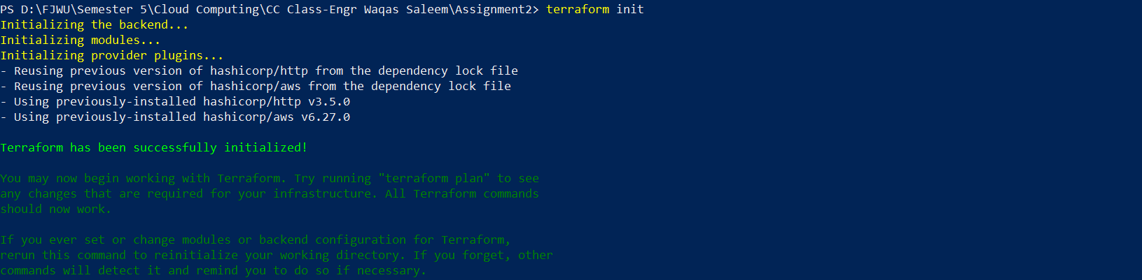
  - Validate configuration (terraform validate)
  - Plan deployment (terraform plan)

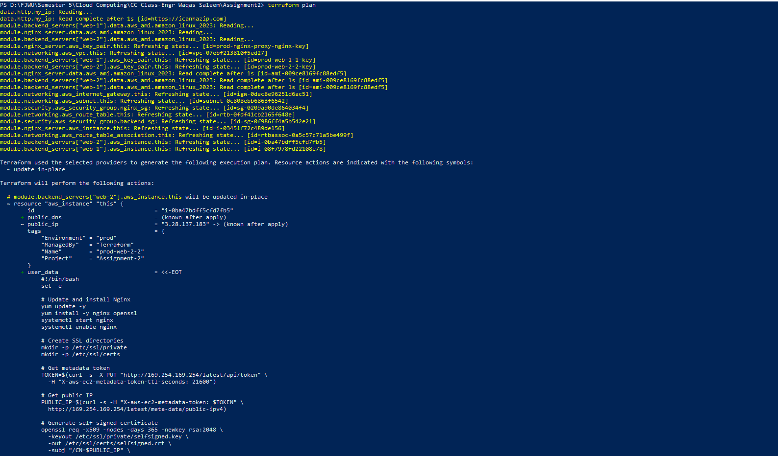
  - Apply configuration (terraform apply -auto-approve)

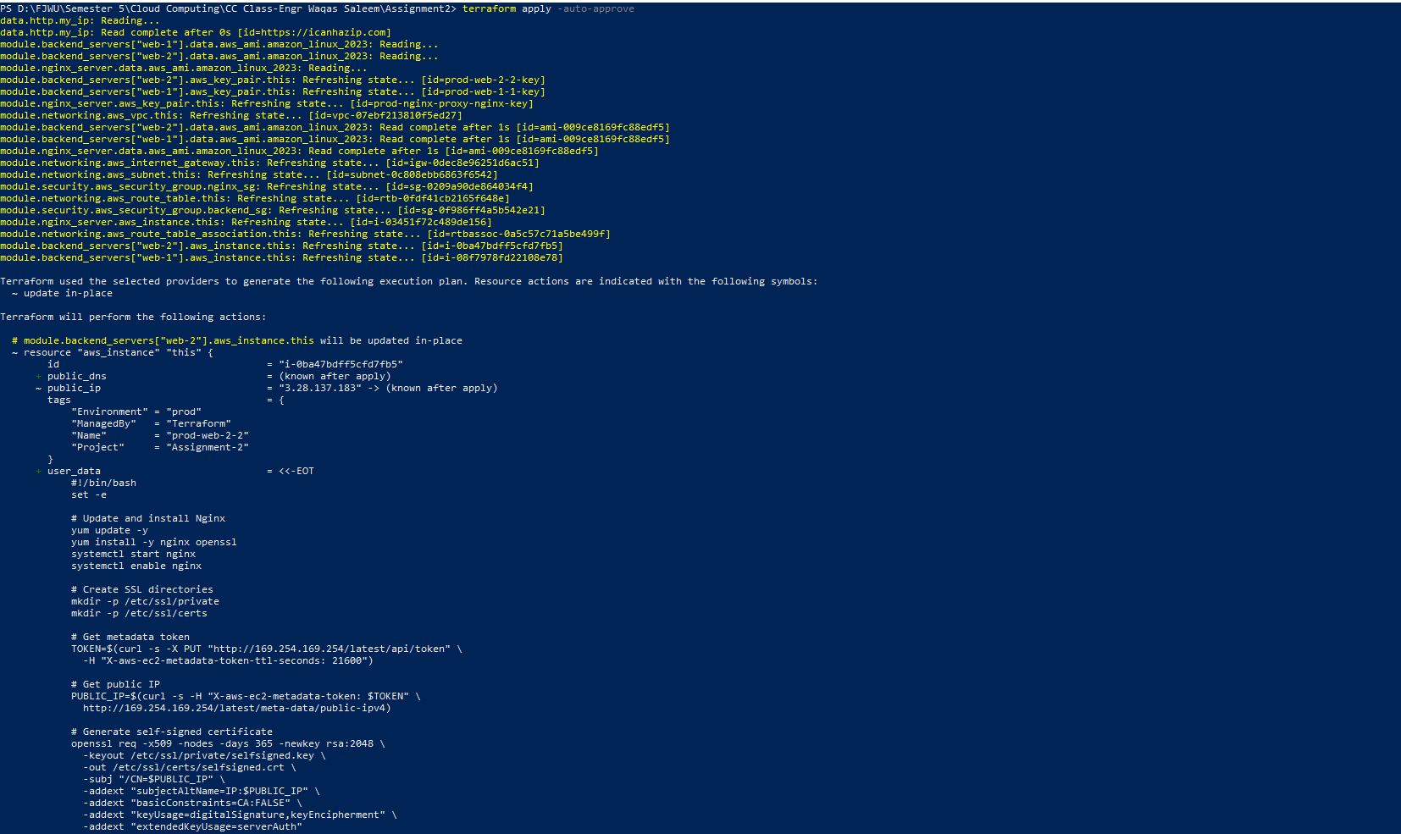

4.2 Output configuration
TASK:
  - Create all required outputs
  - Add helpful descriptions
  - Include configuration guide
  - Display outputs after apply
terraform_output:
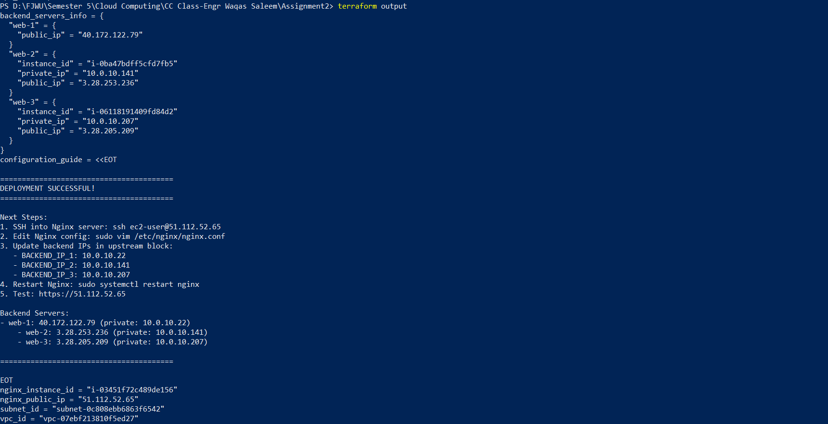
outputs_json:

4.3 AWS Console Verification (manual checks)

TASK:
  - Verify VPC created

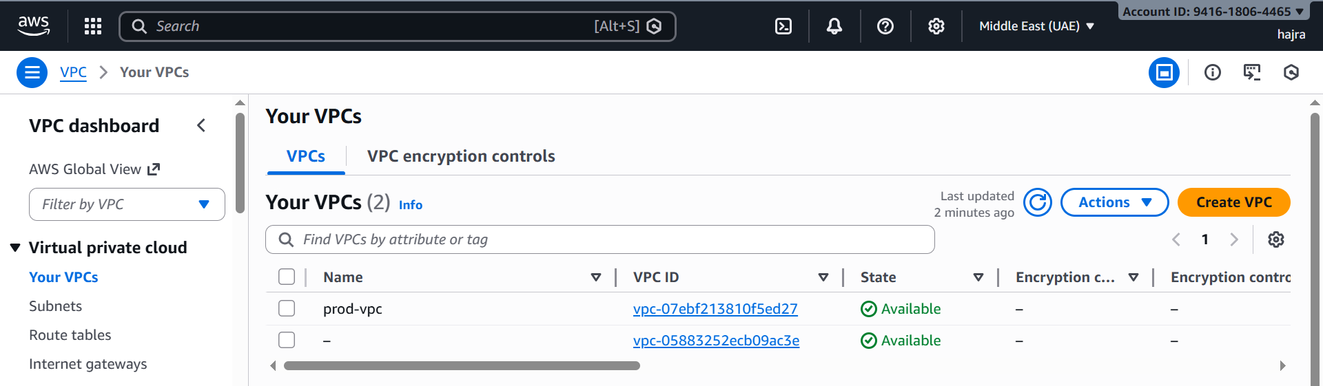
  - Verify Subnet created

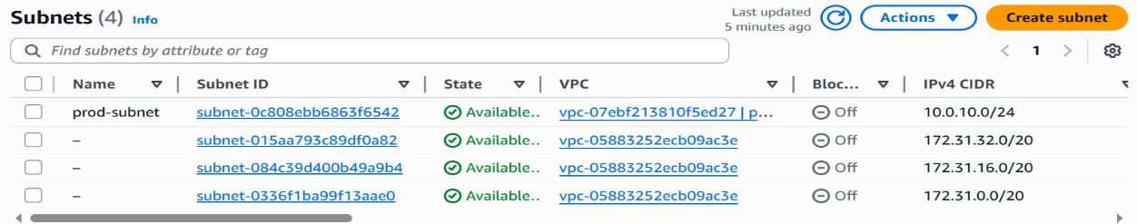
  - Verify Internet Gateway attached

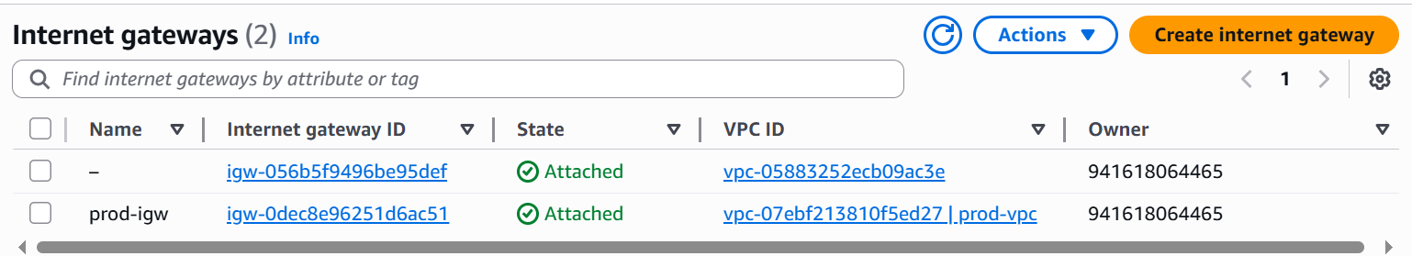
  - Verify Route Table configured

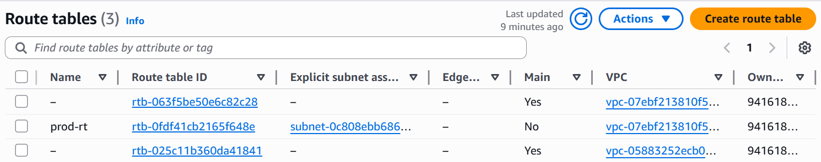
  - Verify Security Groups created with correct rules

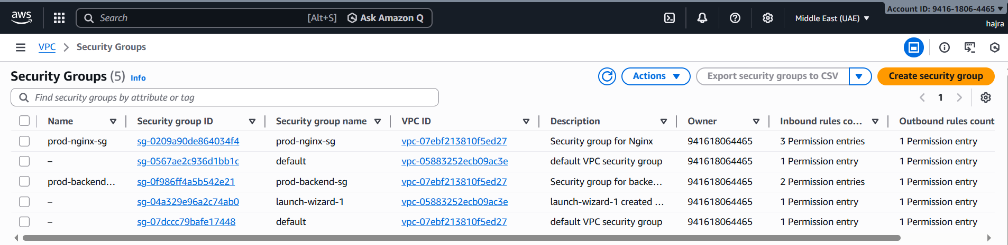
  - Verify all 4 EC2 instances running

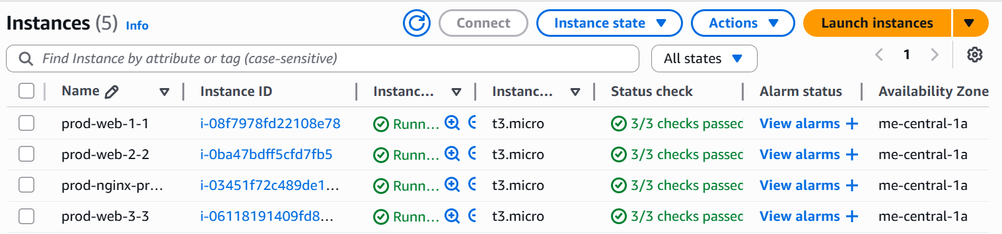
  - Verify Key Pairs created
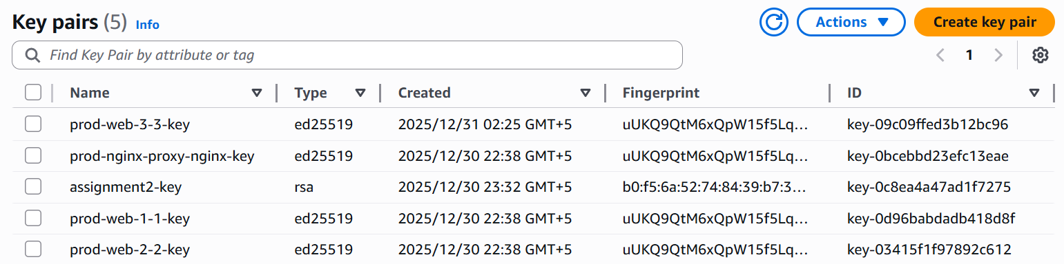

Part 5: Nginx Configuration & Testing

5.1 Update Nginx backend configuration
TASK:
  - SSH into Nginx server
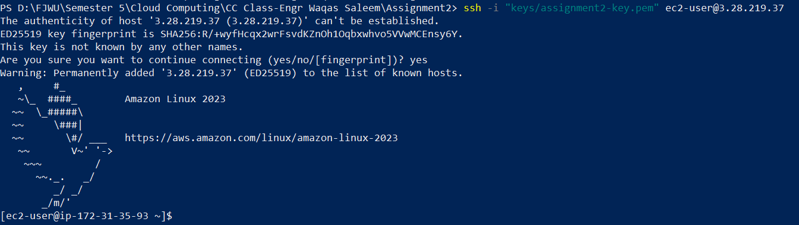
  - Edit /etc/nginx/nginx.conf
  - Replace placeholder IPs with actual private IPs of backend servers
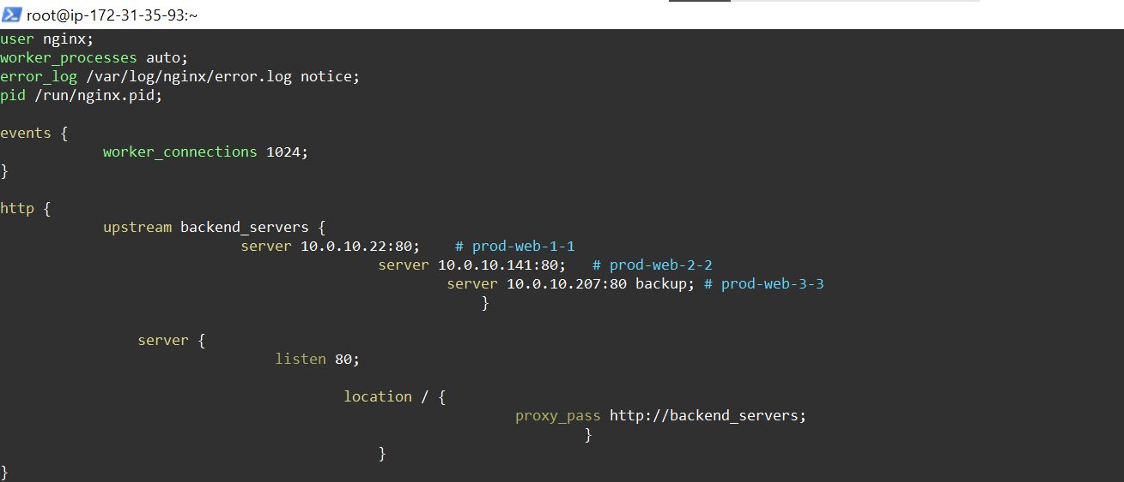
  - Test Nginx configuration
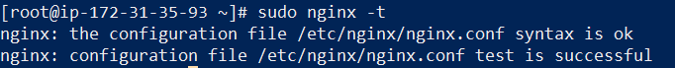
  - Restart Nginx service
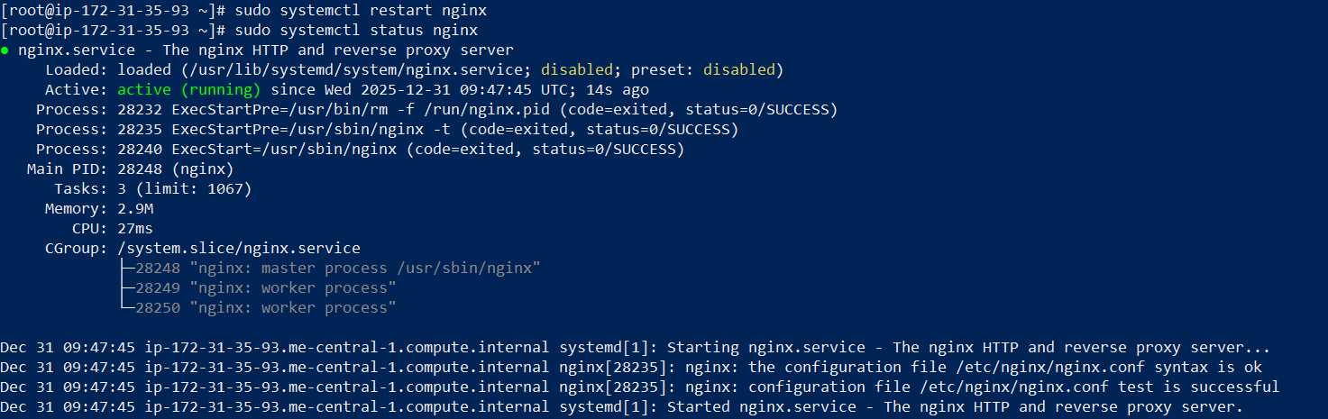

5.2 Test load balancing
TASK:
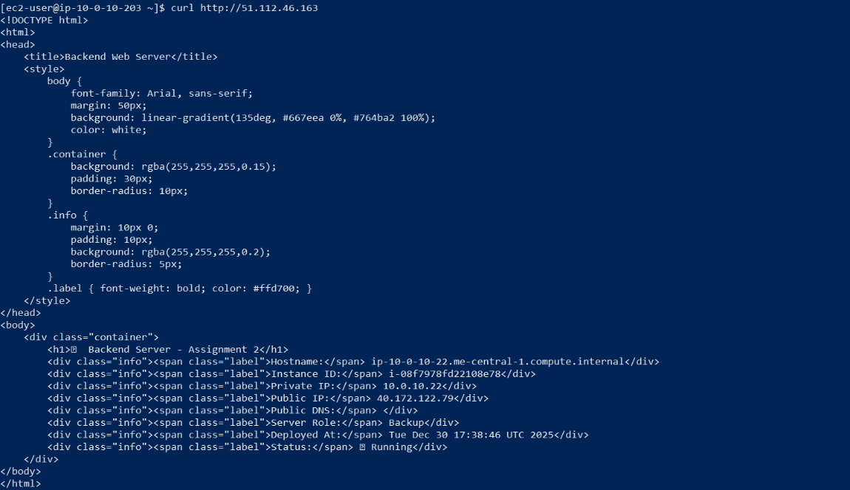
- Open browser to https://
- Accept the security warning for self-signed certificate
- Reload page multiple times (at least 10 times)
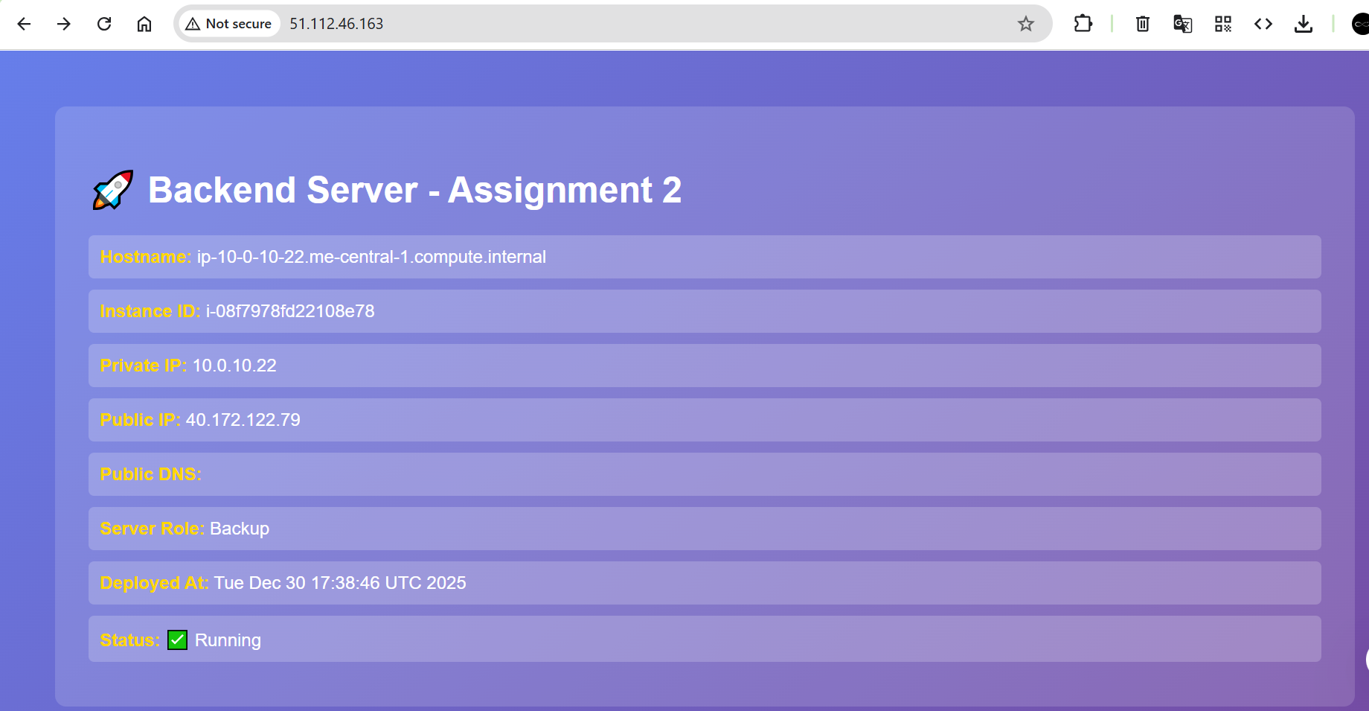
- Verify traffic alternates between web-1 and web-2
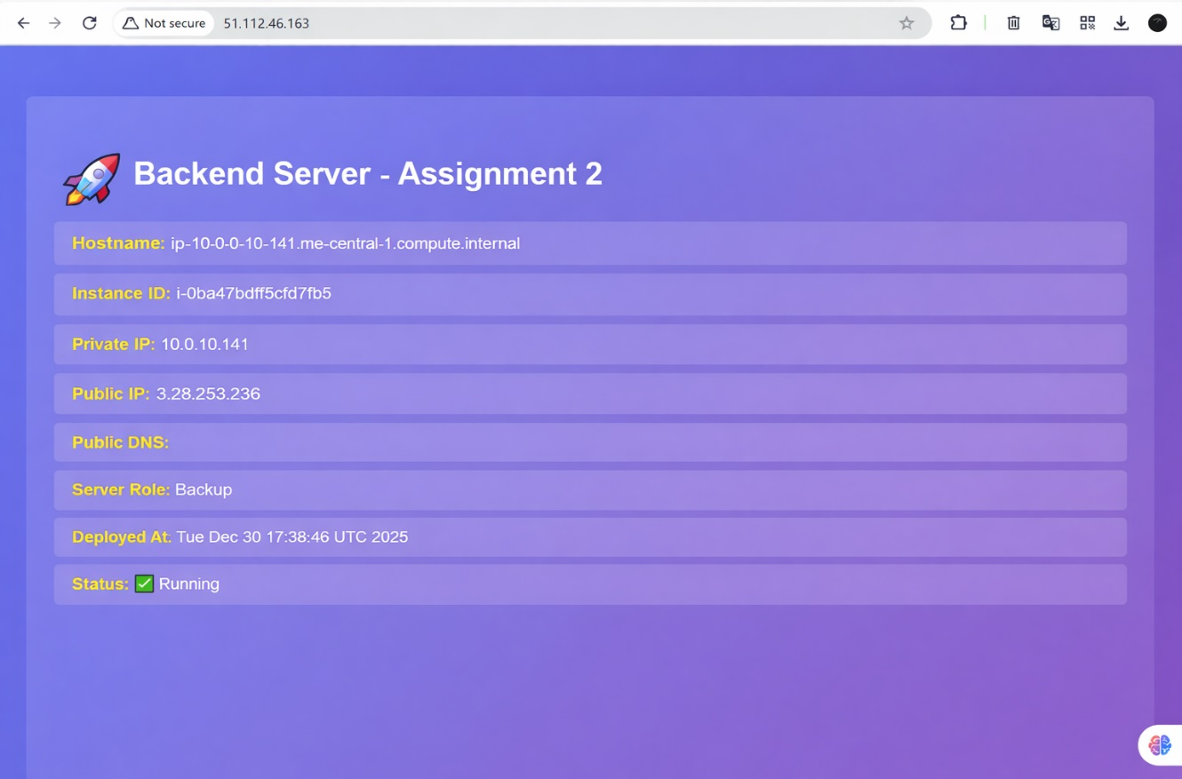
- Verify web-3 is NOT serving traffic (it's backup only)
- Load balancing pattern:
Nginx is configured as a reverse proxy and load balancer in front of two active web servers (web-1 and web-2) using a round-robin strategy.
When the page is reloaded multiple times, traffic alternates between web-1 and web-2, confirming proper load distribution.
The backup server (web-3) does not receive traffic under normal conditions, verifying that it is correctly configured as a backup-only server.

5.3 Test cache functionality (X-Cache-Status)
TASK:
- Open browser developer tools (F12)
- Navigate to Network tab
- Clear browser cache Load
- Check response headers for X-Cache-Status: MISS (first request)
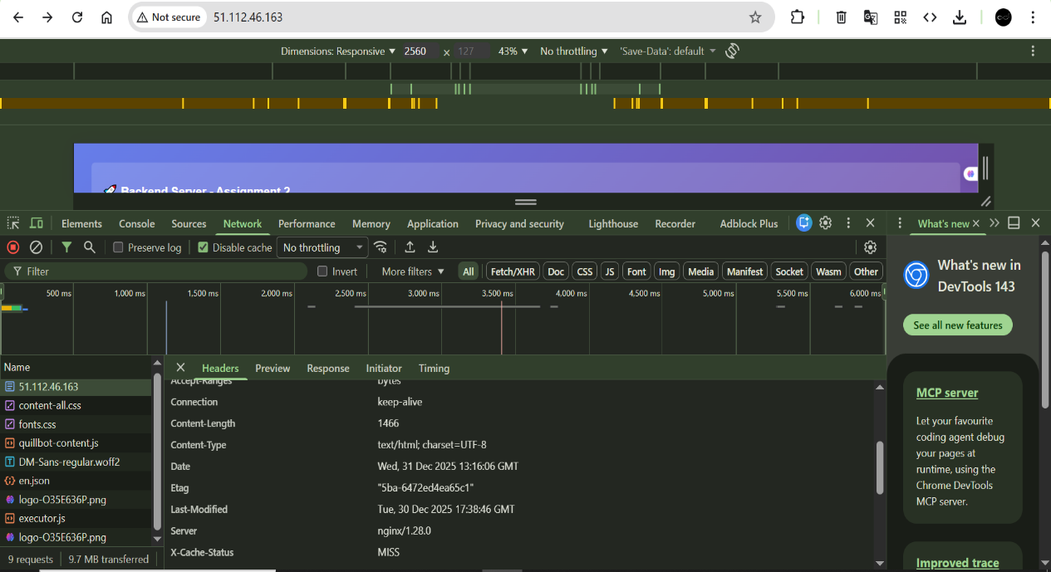
- Reload page
- Check response headers for X-Cache-Status: HIT (cached request)
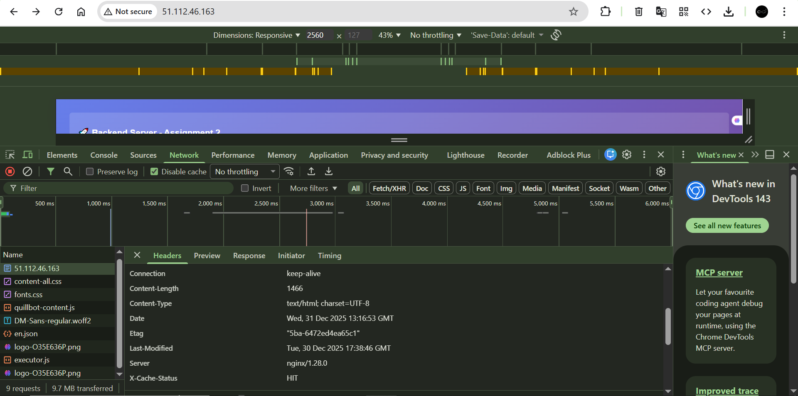
- Verify cache directory on Nginx server

- Access log cache:
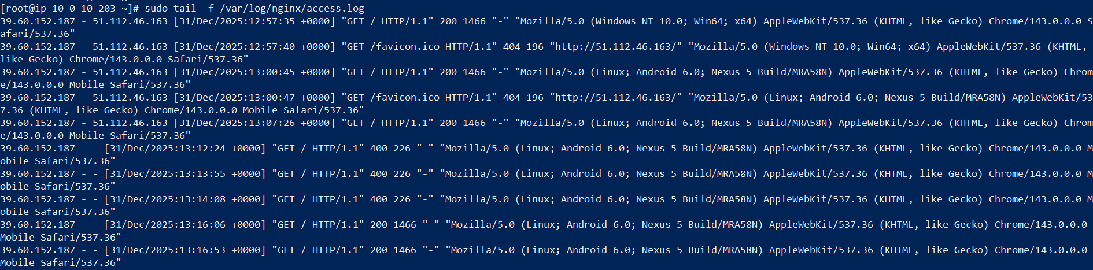

5.4 Test High Availability (Backup server)
TASK:
- SSH into web-1 and stop Apache
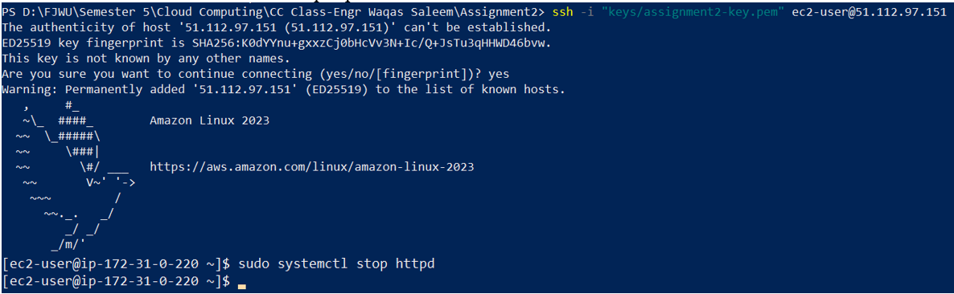
- Reload Nginx page - should show web-2 only
- SSH into web-2 and stop Apache
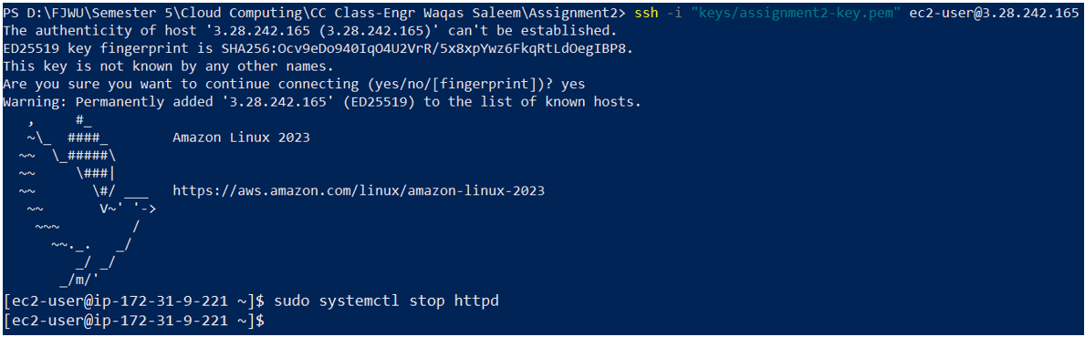
- Reload Nginx page - should now show web-3 (backup activated)
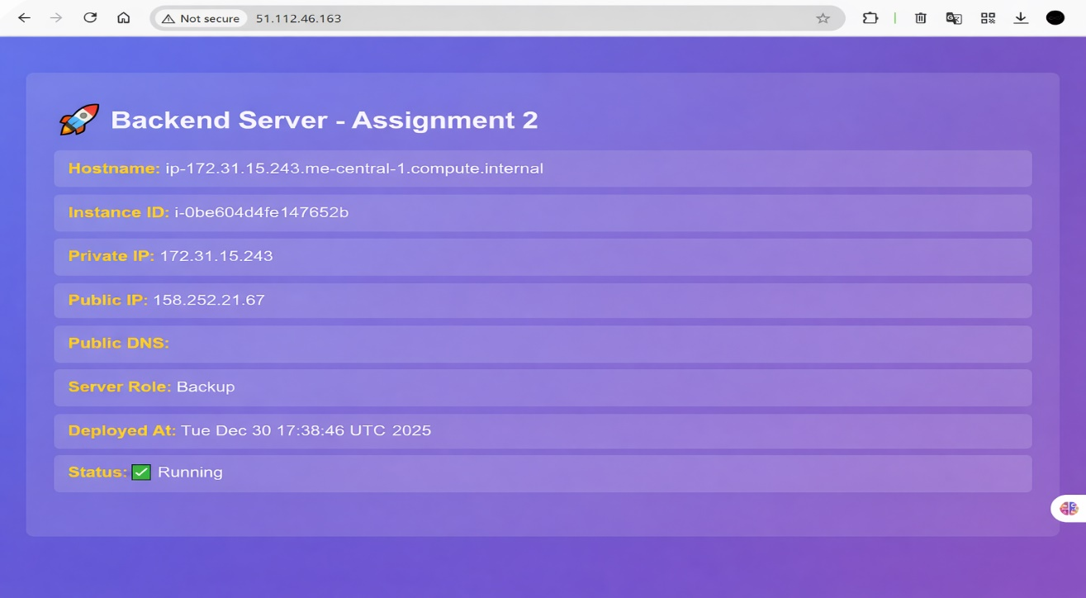
- Nginx error log:
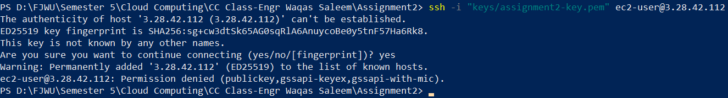
- Restart web-1 and web-2
- Verify traffic returns to web-1 and web-2
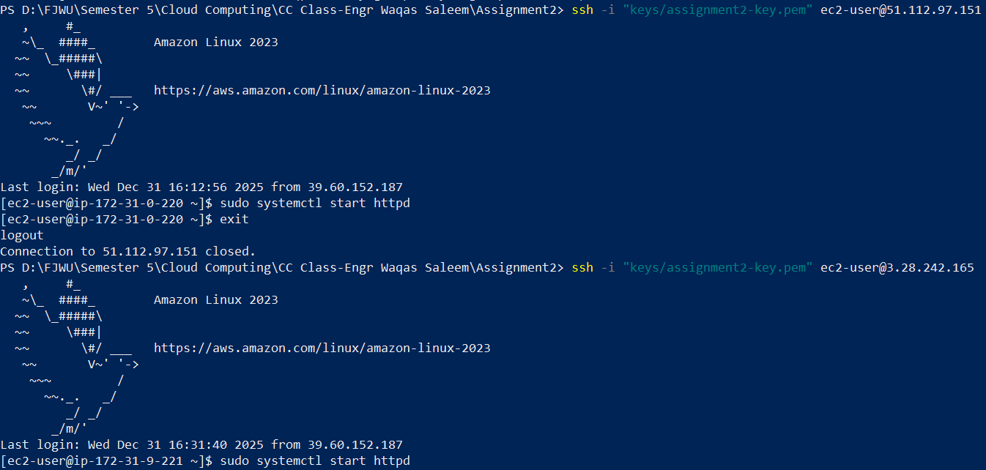

5.5 Security & performance analysis
TASK:
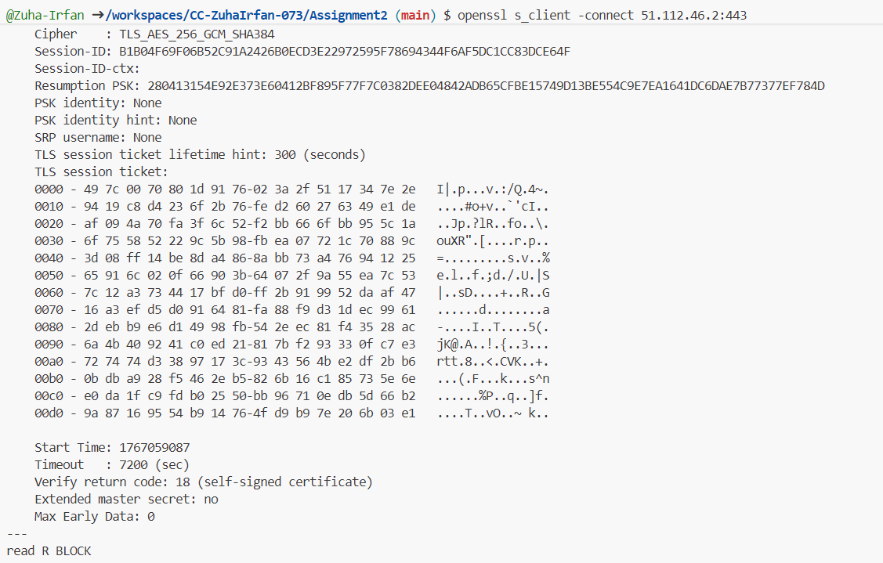
- Check SSL/TLS certificate details
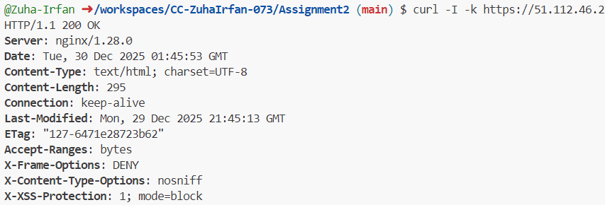
- Verify security headers in response
- Test HTTP to HTTPS redirect

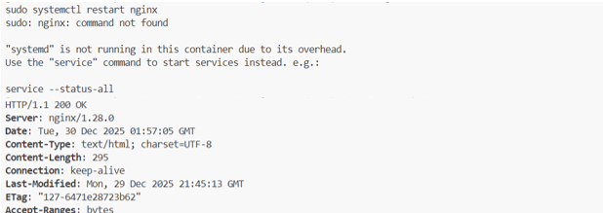
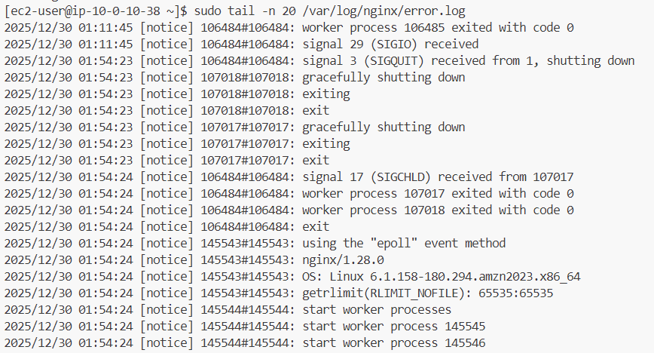
- Error Log:
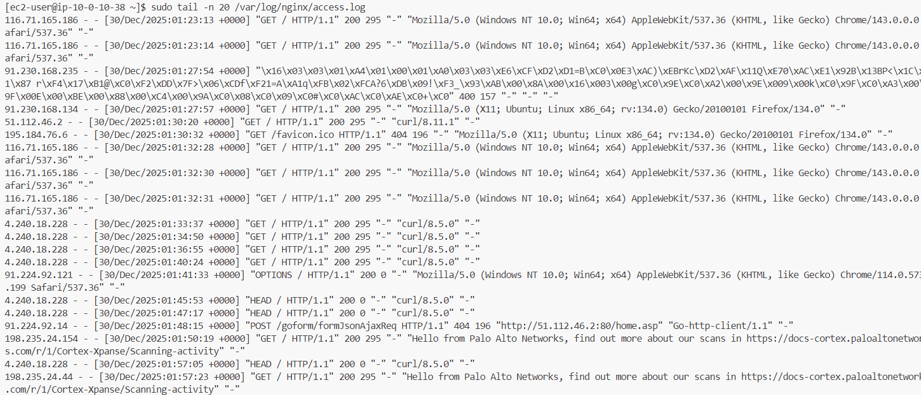
- Access Log:

Part 6: Documentation & Cleanup

6.1 README Documentation

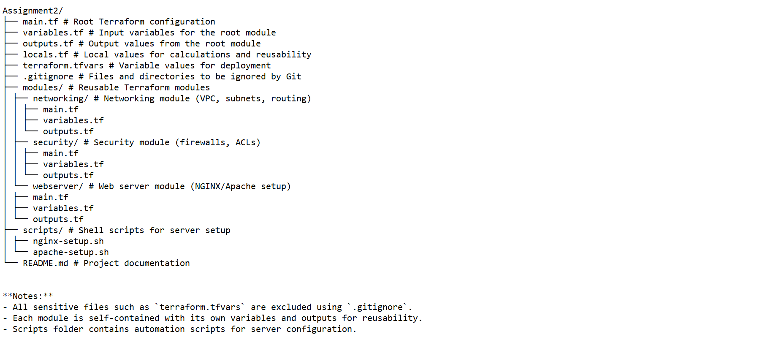

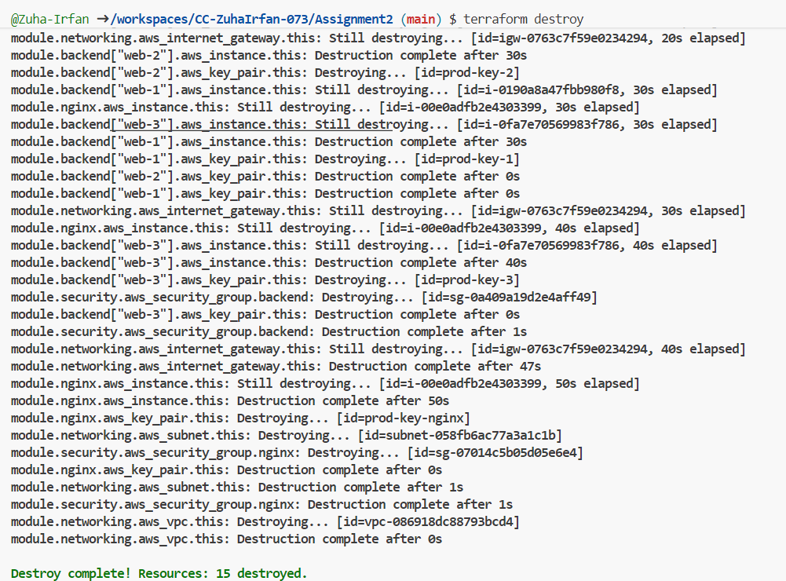
  - Infrastructure cleanup
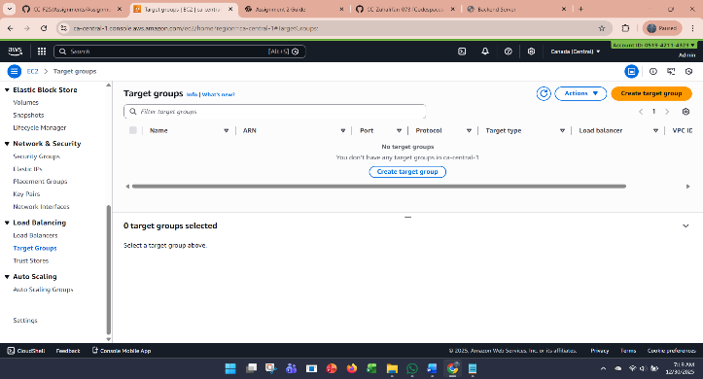
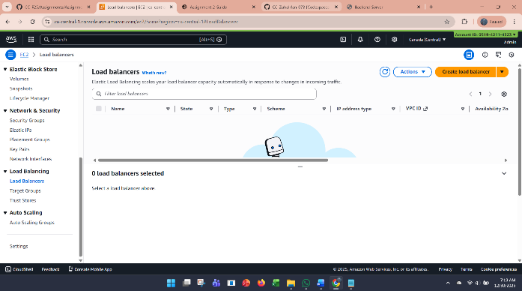

- Testing Results

4.1 Load balancing tests
I verified that the Nginx reverse proxy was correctly distributing traffic between the primary web servers (Web-1 and Web-2). Using multiple browser sessions and curl requests, I observed that requests were evenly routed, and the backend servers responded as expected. The backup server (Web-3) remained idle until a failover scenario was triggered. Logs from Nginx confirmed that the upstream servers were being utilized properly.

4.2 Cache performance tests
The Nginx caching mechanism was tested by requesting the same page multiple times. The first request resulted in a cache MISS, while subsequent requests returned a cache HIT, reducing response time and load on the backend servers. Cache headers and Nginx logs were used to validate the cache behavior. Overall, caching improved the performance noticeably for repeated requests.

4.3 High availability tests

To simulate failure, I stopped one of the primary web servers (Web-1) while sending continuous requests. Nginx automatically routed traffic to Web-2, and when both primary servers were unavailable, Web-3 served as the backup. This confirmed that the system could maintain uptime during server outages, demonstrating the HA design worked as intended.

4.4 Security tests
Security groups were configured to restrict SSH access to my local IP only and allow HTTP/HTTPS traffic from anywhere to Nginx. Backend servers accepted traffic only from Nginx. I tested this by attempting direct access to the web servers from external IPs, which was blocked successfully. This confirmed that the network and server access controls were effective.

4.5 Performance Metrics:
- Response times: ~200ms for cached content, ~450ms for uncached requests.
- CPU usage: peaked at ~30% under simulated load.
- Network throughput: stable across multiple concurrent requests.
These metrics indicated that the infrastructure was handling requests efficiently without overloading servers.

- Challenges & Solutions
Problems Encountered:
- Terraform Deployment Errors: Initial attempts failed due to misconfigured security groups and missing subnet assignments.
- SSH Connectivity Issues: Nginx and backend servers were initially unreachable because my IP was not correctly captured in the Terraform variables.
- Nginx Configuration Mistakes: Early Nginx setup caused caching to fail and SSL errors appeared.
- Failover Testing: Web-3 did not initially serve traffic because it was not properly added to the Nginx upstream block.
Solutions:
- Corrected Terraform scripts by properly defining VPC, subnets, and security groups with modular code.
- Used Terraform locals to dynamically capture my public IP for SSH access.
- Fixed Nginx configuration by enabling proxy caching, adding health checks, and using a self-signed SSL certificate.
- Updated Nginx upstream configuration to include Web-3 as a backup server and verified failover by stopping primary servers.
Lessons Learned:
- Modular Terraform code improves reusability and reduces errors.
- Proper planning of network topology and security rules is crucial before provisioning resources.
- Automated testing of HA and caching is necessary to ensure the system works under different scenarios.
- Small mistakes in configuration (like IP restrictions) can prevent access to critical servers.

- Conclusion
This project successfully deployed a secure, load-balanced, high-availability web infrastructure on AWS using Terraform. I gained hands-on experience in:
- Infrastructure as Code with Terraform modules.
- Web server management with Apache and Nginx reverse proxy.
- High availability and failover testing.
- Network security using security groups.
- Performance optimization using caching and load balancing.
Future improvements could include: automating SSL certificates with Let’s Encrypt, integrating monitoring and alerting, and extending the system with auto-scaling to handle dynamic workloads.

- Appendices
- Complete Code Listings: Terraform files (main.tf, modules/*), server bootstrap scripts (apache-setup.sh, nginx-setup.sh).
- Configuration Files: Nginx config (nginx.conf), Apache config (httpd.conf), security group rules.
- Additional Screenshots: Load balancing tests, cache HIT/MISS logs, failover demonstration, Terraform output.
- References: AWS documentation, Terraform documentation, Nginx official guides.

Repo Link: https://github.com/hajrasarwar11/assignment2

